Name: | Muhammad Taha
CMS ID: | 518133

Lesson Set 6 | The While LOOP
Purpose | - Understand the purpose and usage of Boolean and relational operators.  - Understand the selection statement.  - Usage of if-else statements.  - To introduce the concept of selecting statements using relational operators.
Procedure | - Students should read the Pre-lab Reading Assignment before coming to lab.  - Students should complete the Pre-lab Writing Assignment before coming to lab.  - In the lab, students should complete Labs 6.1 through 6.4 in sequence.  - Your instructor will give further instructions as to grading and completion of the lab.  - Students should complete the set of lab tasks before the next lab and get them checked by their lab instructor.
 | Contents | Pre-requisites | Completion Time | Page Number
 | Pre-lab Reading Assignment | - | 20 min | 2
 | Pre-lab Writing Assignment | Pre-lab Reading | 10 min | 6
 | Lab 6
 | Lab 6.1  Working While loop | Pre-lab reading | 30 min | 7
 | Lab 6.2  Working while loop with if-else | Understanding of  While loop and if-else | 30 min | 7
 | Lab 6.3  While loop with arithmetic operators. | Understanding of  While loop and arithmetic operators | 30 min | 8
 | Lab 6.4  Lab Tasks | Understanding of  While and do-while loop | 60 min | 9

PRE-LAB READING ASSIGNMENT
The While Loop | Often in programming one needs a statement or block of statements to repeat during execution. This can be accomplished using a loop. A loop is a control structure that causes repetition of code within a program. C++ has three types of loops. The first we will consider is the while loop. The syntax is the following:  while (expression)  {  statement_1;  statement_2;  :  statement_n;  }  If there is only one statement, then the curly braces can be omitted. When a while loop is encountered during execution, the expression is tested to see if it is true or false. The block of statements is repeated as long as the expression is true. Consider the following:  #include <iostream>  using namespace std;  int main()  {  int num = 5;  int numFac = 1;  while (num > 0)  {  numFac = numFac * num;  num––; // note the use of the decrement operator  }  cout << " 5! = " << numFac << endl;  return 0;  }  This program computes 5! = 5 * 4 * 3 * 2 * 1 and then prints the result to the screen. Note how the while loop controls the execution. Since num = 5 when the while loop is first encountered, the block of statements in the body of the loop is executed at least once. In fact, the block is executed 5 times because of the decrement operator which forces the value of num to decrease by one every time the block is executed. During the fifth iteration of the loop num becomes 0, so the next time the expression is tested num > 0 is false and the loop is exited. Then the cout statement is executed.  What do you think will happen if we eliminated the decrement operator num–– in the above code? The value of num is always 5. This means that the expression num > 0 is always true! If we try to execute the modified program, the result is an infinite loop, i.e., a block of code that will repeat forever. One must be very cautious when using loops to ensure that the loop will terminate. Here is another example where the user may have trouble with termination.  #include <iostream>  using namespace std;  int main()  {  char letter = 'a';  while (letter != 'x')  {  cout << "Please enter a letter" << endl;  cin >> letter;  cout << "The letter your entered is " << letter << endl;  }  return 0;  }  Note that this program requires input from the user during execution. Infinite loops can be avoided, but it would help if the user knew that the 'x' character terminates the execution. Without this knowledge, the user could continually enter characters other than 'x' and never realize how to terminate the program. In the lab assignments you will be asked to modify this program to make it more user-friendly.
Counters | Often a programmer needs to control the number of times a particular loop is repeated. One common way to accomplish this is by using a counter. For example, suppose we want to find the average of five test scores. We must first input and add the five scores. This can be done with a counter-controlled loop as shown in Sample Program 5.3. Notice how the variable named test works as a counter. Also, notice the use of a constant for the number of tests. This is done so that the number of tests can easily be changed if we want a different number of tests to be averaged.  #include <iostream>  using namespace std;  const int NUMBEROFTESTS = 5;  int main()  {  int score ; // the individual score read in  float total = 0.0; // the total of the scores  float average; // the average of the scores  int test = 1; // counter that controls the loop  while (test <= NUMBEROFTESTS) // Note that test is 1 the first time  // the expression is tested  {  cout << "Enter your score on test " << test << ": " << endl;  cin >> score;  total = total + score;  test++;  }  average = total / NUMBEROFTESTS;  cout << "Your average based on " << NUMBEROFTESTS  << " test scores is " << average << endl;  return 0;  }  Above program can be made more flexible by adding an integer variable called numScores that would allow the user to input the number of tests to be processed.
Sentinel Values | We can also control the execution of a loop by using a sentinel value which is a special value that marks the end of a list of values. In a variation of the previous program example, if we do not know exactly how many test scores there are, we can input scores which are added to the total until the sentinel value is input. Sample Program 5.4 revises Sample Program 5.3 to control the loop with a sentinel value. The sentinel in this case is -1 since it is an invalid test score. It does not make sense to use a sentinel between 0 and 100 since this is the range of valid test scores. Notice that a counter is still used to keep track of the number of test scores entered, although it does not control the loop. What happens if the first value the user enters is a -1?  #include <iostream>  using namespace std;  int main()  {  int score ; // the individual score read in  float total = 0.0; // the total of the scores  float average; // the average of the scores  int test = 1; // counter that controls the loop  cout << "Enter your score on test " << test  << " (or -1 to exit): " << endl;  cin >> score; // Read the 1st score  while (score != -1) // While we have not entered the sentinel  // (ending) value, do the loop  {  total = total + score;  test++;  cout << "Enter your score on test " << test  << " (or -1 to exit): " << endl;  cin >> score; // Read the next score  }  if (test > 1) // If test = 1, no scores were entered  {  average = total / (test - 1);  cout << "Your average based on " << (test - 1)  << " test scores is " << average << endl;  }  return 0;  }  Notice that the program asks for input just before the while loop begins and again as the last instruction in the while loop. This is done so that the while loop can test for sentinel data. Often this is called priming the read and is frequently implemented when sentinel data is used to end a loop.
Data Validation | One nice application of the while loop is data validation. The user can input data (from the keyboard or a file) and then a while loop tests to see if the value(s) is valid. The loop is skipped for all valid input but for invalid input the loop is executed and prompts the user to enter new (valid) input. The following is an example of data validation.  cout << "Please input your choice of drink "  << "(a number from 1 to 4 or 0 to quit)" << endl;  cout << " 1 - Coffee" << endl<< " 2 - Tea" << endl  << " 3 - Coke" << endl<< " 4 - Orange Juice" << endl << endl<< " 0 - QUIT" << endl << endl;  cin >> beverage;  while (beverage < 0 || beverage > 4)  cin >> beverage;  What type of invalid data does this code test for? If beverage is an integer variable, what happens if the user enters the character ‘$’ or the float 2.9?
The Do-While Loop | The while loop is a pre-test or top test loop. Since we test the expression before entering the loop, if the test expression in the while loop is initially false, then no iterations of the loop will be executed. If the programmer wants the loop to be executed at least once, then a post-test or bottom test loop should be used. C++ provides the do-while loop for this purpose. A do-while loop is similar to a while loop except that the statements inside the loop body are executed before the expression is tested. The format for a single statement in the loop body is the  following:  do  statement;  while (expression);  Note that the statement must be executed once even if the expression is false. To see the difference between these two loops consider the code:  int num1 = 5;  int num2 = 7;  while (num2 < num1)  {  num1 = num1 + 1;  num2 = num2 - 1;  }  Here the statements num1 = num1 + 1 and num2 = num2 - 1 are never executed since the test expression num2 < num1 is initially false. However, we get a different result using a do-while loop:  int num1 = 5;  int num2 = 7;  do  {  num1 = num1 + 1;  num2 = num2 - 1;  } while (num2 < num1);  In this code the statements num1 = num1 + 1 and num2 = num2 - 1 are executed exactly once. At this point num1 = 6 and num2 = 6 so the expression num2 < num1 is false. Consequently, the program exits the loop and moves to the next section of code. Also note that since we need a block of statements in the loop body, curly braces must be placed around the statements. In Lab 5.2 you will see how do-while loops can be useful for programs that involve a repeating menu.

Pre lab writing assignment
Fill in the blanks | - A block of code that repeats forever is called Infinite Loop.  - To keep track of the number of times a particular loop is repeated, one can use a (n) Counter Controlled Loop  - An event-controlled loop that is always executed at least once is the  - Do While Loop  - An event-controlled loop that is not guaranteed to execute at least once is the While  - In the conditional if (++number < 9), the comparison number < 9 is made First and number is incremented After  (Choose first or second for each blank.  - In the conditional if (number++ < 9), the comparison number < 9 is made First and number is incremented After  (Choose first or second for each blank.)

Lab 6
Lab 6.1 | - Once you have opened the visual studio copy the following code in the code editor, try to run the code and observe the output. Write down the output that appears on the screen in the space given below  #include <iostream>  using namespace std;  int main()  {  char letter = 'a';  while (letter != 'x')  {  cout <<"Please enter a letter" << endl;  cin >> letter;  cout <<"The letter you entered is "<< letter << endl;  }  return 0;  }  Please enter a letter  e  The letter you entered is e  Please enter a letter  f  The letter you entered is f  Please enter a letter  x  The letter you entered is x
Lab 6.2 | - Create a new project with new file called lab6.2.cpp, copy the following code it and try to fill the missing code of the program. Observe the output that appears and write it in the box given below  #include <iostream>  using namespace std;  int main() {  int month = 1;  float total = 0, rain;  cout << "Enter the total rainfall for month " << month << " (Enter -1 when you are finished): " << endl;  cin >> rain;  while (rain != -1) {  total += rain;  month++;  cout << "Enter the total rainfall in inches for month " << month << " (Enter -1 when you are finished): " << endl;  cin >> rain; // Read in the new value for rain  }  if (month == 1) {  cout << "No data has been entered" << endl;  } else {  cout << "The total rainfall for " << month - 1 << " months is " << total << " inches." << endl;  }  return 0;  }  Enter the total rainfall for month 1 (Enter -1 when you are finished):  4  Enter the total rainfall in inches for month 2 (Enter -1 when you are finished):  34  Enter the total rainfall in inches for month 3 (Enter -1 when you are finished):  12  Enter the total rainfall in inches for month 4 (Enter -1 when you are finished):  22  Enter the total rainfall in inches for month 5 (Enter -1 when you are finished):  1  Enter the total rainfall in inches for month 6 (Enter -1 when you are finished):  -1  The total rainfall for 5 months is 73 inches.
Lab 6.3 | - Create a new project called 6.3.cpp, copy the following code it and try to run the program. Observe the output that appears and write it in the box given below  #include <iostream>  using namespace std;  void main ()  {  int n;  n=1;  while(n<=10)  {  cout<< n << “ “<< n*n<<endl;  n++;  }  }  1 1  2 4  3 9  4 16  5 25  6 36  7 49  8 64  9 81  10 100

Lab 6.4 | Lab Tasks

- Write a c++ program that inputs a number from user and display a table of that number using
while loop.
#include <iostream>
using namespace std;
int main ()
{
int n,i;

cout<<"Enter the Number For the table:"<<endl;
cin>>n;
while(i<=10)
{ i=1;
cout<< n*i<<endl; i++;

}

}
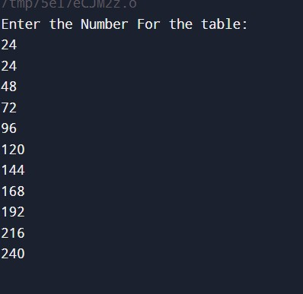

- Write a c++ program that inputs a number from user and display a factorial of that number using while loop.
- #include <iostream>
- using namespace std;

- int main() {
- int number, factorial = 1;
- cout << "Enter a positive integer: ";
- cin >> number;
- if (number < 0) {
- cout << "Factorial is not defined for negative numbers." << endl;
- } else {
- int i = 1;
- while (i <= number) {
- factorial *= i;
- i++;
- }
- cout << "The factorial of " << number << " is " << factorial << "." << endl;
- }

- return 0;
- }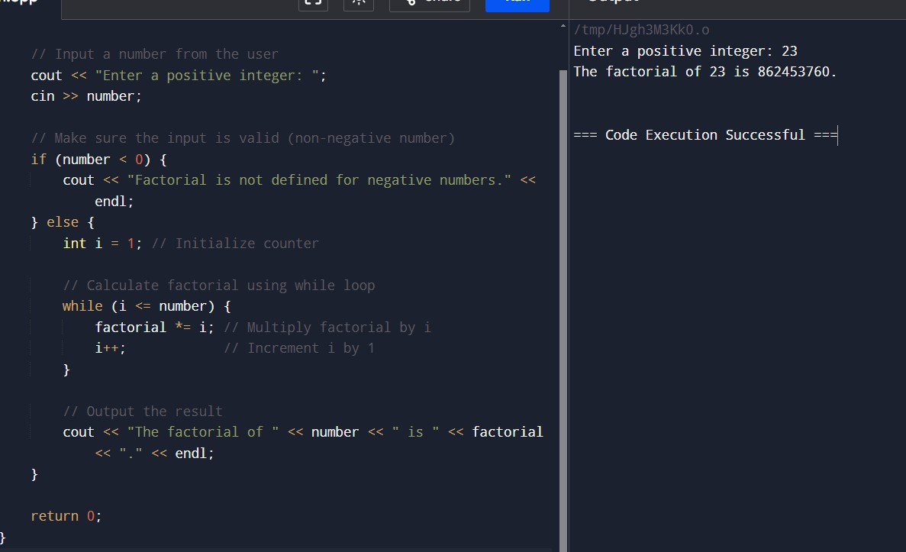

- Bonus Question:

Write a program that gets two numbers from user and display the result of first number raise to power of second number using do-while loop.
